SIMATS ENGINEERING

ASSESSMENT TOOL 4

COURSE NAME: Database Management Systems COURSE CODE: CSA05

COURSE OUTCOME COVERED

CO2: Apply the relational model, relational algebra, SQL query structures, and views to solve database querying and data manipulation problems. (BL3, BL6)

Activity Tool : Analytical Problem Solving (High) Assessment Tool Weightage: 35%

Dr

QUESTIONS Total Marks: 50
Q.No | Question | Bloom's Level | Marks
1 | Apply relational algebra operations (σ, π, ∪, -, ×, ⋈) on the given Employee and Department relations to retrieve required records. | BL3 – Apply | 5
2 | Write SQL DDL statements to create STUDENT(SID, Name, DOB, DeptID) and DEPARTMENT(DeptID, DeptName) tables with all appropriate constraints. | BL3 – Apply | 5
3 | Formulate SQL queries using GROUP BY, HAVING, and aggregate functions (COUNT, SUM, AVG, MAX, MIN) on a given Sales dataset. | BL3 – Apply | 5
4 | Write a correlated sub-query to find employees earning more than the average salary of their own department. | BL3 – Apply | 5
5 | Apply all types of JOIN operations (INNER, LEFT OUTER, RIGHT OUTER, FULL OUTER, CROSS) on Employee and Project tables. | BL3 – Apply | 5
6 | Create a view 'DeptSalaryView' that displays department name, total employees, and average salary. Write a query on this view. | BL6 – Create | 5
7 | Construct a relational algebra expression for the following: Find names of students who are enrolled in all courses offered. | BL6 – Create | 5
8 | Write SQL DML statements (INSERT, UPDATE, DELETE) with | BL3 – Apply | 5

 | integrity constraint enforcement for a given scenario.
9 | Apply tuple relational calculus to express a query: Find all employees who work in the 'IT' department and earn more than 50000. | BL3 – Apply | 5
10 | Design a relational schema for an Airline Reservation System and write 5 SQL queries demonstrating joins, sub-queries, and views. | BL6 – Create | 5

Code of Conduct:

I Vishal kruthik (192521179) certify that this submission is my original work and that I have adhered to the guidelines specified for this assessment. I understand that any violation of academic integrity rules will result in disciplinary action.

Signature of the student:


RUBRICS FOR CALCULATION:

Numerical Problems
Criteria | Weightag e | Level 4 (Exemplary) | Level 3 (Proficient) | Level 2 (Developing) | Level 1 (Beginning)
Problem Understandin g | 20% | Clearly interprets problem, identifies all parameters and requirements accurately | Understands problem with minor gaps | Partial understanding  ; misses key elements | Misinterprets or unable to understand problem
Method Selection | 20% | Selects most appropriate  method/formul a with strong justification | Selects correct method with minor errors | Inappropriate or partially correct method | Unable to select method
Solution Process | 25% | Logical, systematic steps with | Mostly correct steps with minor | Disorganized steps; multiple errors | No clear process

 |  | correct approach  throughout | mistakes
Accuracy of Calculation | 20% | All calculations accurate; correct final answer | Minor calculation errors | Frequent errors; incorrect final answer | No valid calculations
Interpretation of Results | 15% | Clearly interprets results with units and engineering relevance | Basic interpretatio n with minor omissions | Limited or unclear interpretation | No interpretatio n

Q1. Relational Algebra Operations (σ, π, ∪, −, ×, ⋈) — 5 Marks
Given relations:
EmpID | EName | Salary | DeptID
E01 | Arun | 45000 | D01
E02 | Bala | 60000 | D02
E03 | Chitra | 38000 | D01
E04 | Divya | 72000 | D03
Employee(EmpID, EName, Salary, DeptID)

DeptID | DeptName
D01 | Sales
D02 | HR
D03 | Finance
Department(DeptID, DeptName)

(a) Selection (σ) — Employees earning more than 50000
σ Salary > 50000 (Employee)
Result: Bala (60000), Divya (72000)

(b) Projection (π) — Names and salaries only
π EName, Salary (Employee)

(c) Union (∪) — DeptIDs of Employee combined with Department
π DeptID (Employee) ∪ π DeptID (Department)

(d) Set Difference (−) — Departments with no employees
π DeptID (Department) − π DeptID (Employee)

(e) Cartesian Product (×)
Employee × Department
Produces every combination of Employee tuples with Department tuples (4 × 3 = 12 rows).

(f) Natural Join (⋈) — Employee details with department names
Employee ⋈ Department
(equivalent to: σ Employee.DeptID = Department.DeptID (Employee × Department) )
EmpID | EName | Salary | DeptID | DeptName
E01 | Arun | 45000 | D01 | Sales
E02 | Bala | 60000 | D02 | HR
E03 | Chitra | 38000 | D01 | Sales
E04 | Divya | 72000 | D03 | Finance

Q2. SQL DDL — STUDENT and DEPARTMENT Tables — 5 Marks
CREATE TABLE DEPARTMENT (
DeptID VARCHAR(10) PRIMARY KEY,
DeptName VARCHAR(50) NOT NULL UNIQUE
);

CREATE TABLE STUDENT (
SID VARCHAR(10) PRIMARY KEY,
Name VARCHAR(50) NOT NULL,
DOB DATE NOT NULL,
DeptID VARCHAR(10),
CONSTRAINT chk_dob CHECK (DOB <= CURRENT_DATE),
CONSTRAINT fk_student_dept FOREIGN KEY (DeptID)
REFERENCES DEPARTMENT(DeptID)
ON DELETE SET NULL
ON UPDATE CASCADE
);
Constraints applied:
- PRIMARY KEY on DeptID and SID — enforces entity integrity (uniqueness, NOT NULL)
- NOT NULL on Name and DOB — mandatory attributes
- UNIQUE on DeptName — no two departments share a name
- CHECK constraint — DOB cannot be a future date
- FOREIGN KEY on DeptID — enforces referential integrity between STUDENT and DEPARTMENT
- ON DELETE SET NULL / ON UPDATE CASCADE — referential action policy

Q3. GROUP BY, HAVING and Aggregate Functions — 5 Marks
Given table: SALES(SaleID, Product, Region, Salesperson, Amount, SaleDate)

(a) Total sales amount per region
SELECT Region, SUM(Amount) AS TotalSales
FROM SALES
GROUP BY Region;

(b) Number of sales transactions per product
SELECT Product, COUNT(*) AS NumTransactions
FROM SALES
GROUP BY Product;

(c) Average sale amount per salesperson, only where average > 10000
SELECT Salesperson, AVG(Amount) AS AvgSale
FROM SALES
GROUP BY Salesperson
HAVING AVG(Amount) > 10000;

(d) Highest and lowest sale amount overall
SELECT MAX(Amount) AS HighestSale, MIN(Amount) AS LowestSale
FROM SALES;

(e) Regions having more than 5 transactions
SELECT Region, COUNT(*) AS TxnCount
FROM SALES
GROUP BY Region
HAVING COUNT(*) > 5;
Note: WHERE filters rows before grouping; HAVING filters groups after aggregation — HAVING can use aggregate functions, WHERE cannot.

Q4. Correlated Sub-query — Employees earning above their department average — 5 Marks
SELECT E1.EmpID, E1.EName, E1.DeptID, E1.Salary
FROM Employee E1
WHERE E1.Salary > (
SELECT AVG(E2.Salary)
FROM Employee E2
WHERE E2.DeptID = E1.DeptID
);
How it works:
- The inner query re-executes once for every outer row because it references E1.DeptID (the outer table) — this is what makes it 'correlated' as opposed to a simple nested sub-query.
- For each employee E1, the inner query computes the average salary of only that employee's own department.
- The outer WHERE clause keeps employees whose salary exceeds their own department's average.

Q5. JOIN Operations — Employee and Project Tables — 5 Marks
Employee(EmpID, EName, DeptID) and Project(ProjID, ProjName, EmpID)


(a) INNER JOIN — only employees who are assigned to a project
SELECT E.EmpID, E.EName, P.ProjName
FROM Employee E
INNER JOIN Project P ON E.EmpID = P.EmpID;

(b) LEFT OUTER JOIN — all employees, with project if assigned
SELECT E.EmpID, E.EName, P.ProjName
FROM Employee E
LEFT OUTER JOIN Project P ON E.EmpID = P.EmpID;

(c) RIGHT OUTER JOIN — all projects, with employee if assigned
SELECT E.EmpID, E.EName, P.ProjName
FROM Employee E
RIGHT OUTER JOIN Project P ON E.EmpID = P.EmpID;

(d) FULL OUTER JOIN — all employees and all projects
SELECT E.EmpID, E.EName, P.ProjName
FROM Employee E
FULL OUTER JOIN Project P ON E.EmpID = P.EmpID;

(e) CROSS JOIN — every employee paired with every project
SELECT E.EmpID, E.EName, P.ProjName
FROM Employee E
CROSS JOIN Project P;

Q6. View 'DeptSalaryView' — 5 Marks
CREATE VIEW DeptSalaryView AS
SELECT D.DeptName,
COUNT(E.EmpID) AS TotalEmployees,
AVG(E.Salary) AS AvgSalary
FROM Department D
JOIN Employee E ON D.DeptID = E.DeptID
GROUP BY D.DeptName;

Query on the view — departments with average salary above 50000
SELECT *
FROM DeptSalaryView
WHERE AvgSalary > 50000
ORDER BY AvgSalary DESC;
A view is a virtual table stored as a query definition; it does not physically store data but re-executes its defining query whenever referenced, which keeps DeptSalaryView automatically up to date as Employee/Department rows change.

Q7. Relational Algebra — Division — Students Enrolled in All Offered Courses — 5 Marks
Given: Enrollment(SID, CourseID) and Course(CourseID, CourseName)
π SID, CourseID (Enrollment) ÷ π CourseID (Course)
Explanation:
- The DIVISION operator (÷) finds SID values that are paired, in Enrollment, with every CourseID present in the divisor set π CourseID(Course).
- Step 1: Project Enrollment onto (SID, CourseID) — the dividend relation.
- Step 2: Project Course onto (CourseID) — the divisor relation, i.e. the full set of offered courses.
- Step 3: Divide — the result keeps only those SID values for which the set of enrolled CourseIDs is a superset of the divisor set.
Equivalent expressed using basic operators (÷ is derived, not primitive):
π SID (Enrollment)
−
π SID ( ( π SID (Enrollment) × π CourseID (Course) )
− π SID, CourseID (Enrollment) )

Q8. SQL DML with Integrity Constraint Enforcement — 5 Marks
Scenario: STUDENT(SID PK, Name, DOB, DeptID FK → DEPARTMENT)

(a) INSERT — new student (constraint-safe)
INSERT INTO STUDENT (SID, Name, DOB, DeptID)
VALUES ('S101', 'Kavin', '2004-05-12', 'D01');
-- Fails with a foreign key violation if 'D01' does not exist in DEPARTMENT.
-- Fails with a primary key violation if 'S101' already exists.

(b) UPDATE — reassign a student's department
UPDATE STUDENT
SET DeptID = 'D02'
WHERE SID = 'S101';
-- Fails if 'D02' is not a valid DeptID (referential integrity check).

(c) DELETE — remove a department safely
DELETE FROM DEPARTMENT
WHERE DeptID = 'D03';
-- Fails if students still reference 'D03', unless the FK was defined
-- with ON DELETE CASCADE / SET NULL, in which case dependent rows
-- are automatically deleted or nulled to preserve integrity.
In every case the DBMS checks primary-key, foreign-key, NOT NULL and CHECK constraints before committing the change, rejecting (rolling back) any statement that would leave the database in an inconsistent state.

Q9. Tuple Relational Calculus — IT Department, Salary > 50000 — 5 Marks
{ t | t ∈ Employee ∧ t.Dept = 'IT' ∧ t.Salary > 50000 }
Reading of the expression:
- t is a tuple variable ranging over the Employee relation.
- t ∈ Employee restricts t to tuples that actually exist in Employee.
- t.Dept = 'IT' keeps only tuples whose Dept attribute equals 'IT'.
- t.Salary > 50000 further restricts to tuples with salary above 50000.
- The whole set-builder expression returns all employee tuples satisfying both conditions — this is Tuple Relational Calculus (TRC), a declarative, non-procedural query language equivalent in expressive power to relational algebra (safe expressions).
Equivalent SQL:
SELECT * FROM Employee
WHERE Dept = 'IT' AND Salary > 50000;

Q10. Airline Reservation System — Schema Design and 5 SQL Queries — 5 Marks

Relational Schema
- PASSENGER (PassengerID PK, Name, Passport_No, Phone, Email)
- AIRPORT (AirportID PK, AirportName, City, Country)
- AIRCRAFT (AircraftID PK, Model, Capacity, Airline)
- FLIGHT (FlightID PK, FlightNo, AircraftID FK, DepartureAirportID FK, ArrivalAirportID FK, DepartureTime, ArrivalTime)
- BOOKING (BookingID PK, PassengerID FK, FlightID FK, BookingDate, SeatNo, Status)
- PAYMENT (PaymentID PK, BookingID FK, Amount, PaymentDate, PaymentMode)
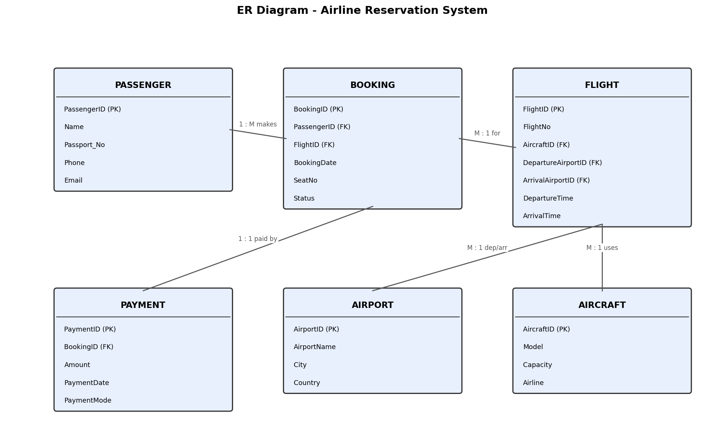

DDL (key tables)
CREATE TABLE PASSENGER (
PassengerID VARCHAR(10) PRIMARY KEY,
Name VARCHAR(50) NOT NULL,
Passport_No VARCHAR(20) UNIQUE,
Phone VARCHAR(15), Email VARCHAR(50)
);
CREATE TABLE FLIGHT (
FlightID VARCHAR(10) PRIMARY KEY,
FlightNo VARCHAR(10) NOT NULL,
AircraftID VARCHAR(10) REFERENCES AIRCRAFT(AircraftID),
DepartureAirportID VARCHAR(10) REFERENCES AIRPORT(AirportID),
ArrivalAirportID VARCHAR(10) REFERENCES AIRPORT(AirportID),
DepartureTime DATETIME, ArrivalTime DATETIME
);
CREATE TABLE BOOKING (
BookingID VARCHAR(10) PRIMARY KEY,
PassengerID VARCHAR(10) REFERENCES PASSENGER(PassengerID),
FlightID VARCHAR(10) REFERENCES FLIGHT(FlightID),
BookingDate DATE, SeatNo VARCHAR(5),
Status VARCHAR(15) CHECK (Status IN ('Confirmed','Cancelled','Waitlisted'))
);

Query 1 — JOIN: passenger name with their flight number and route
SELECT P.Name, F.FlightNo, A1.City AS FromCity, A2.City AS ToCity
FROM BOOKING B
JOIN PASSENGER P ON B.PassengerID = P.PassengerID
JOIN FLIGHT F ON B.FlightID = F.FlightID
JOIN AIRPORT A1 ON F.DepartureAirportID = A1.AirportID
JOIN AIRPORT A2 ON F.ArrivalAirportID = A2.AirportID;

Query 2 — LEFT OUTER JOIN: all flights, even those with zero bookings
SELECT F.FlightNo, COUNT(B.BookingID) AS TotalBookings
FROM FLIGHT F
LEFT OUTER JOIN BOOKING B ON F.FlightID = B.FlightID
GROUP BY F.FlightNo;

Query 3 — Sub-query: passengers who paid above the average payment amount
SELECT P.Name, PM.Amount
FROM PASSENGER P
JOIN BOOKING B ON P.PassengerID = B.PassengerID
JOIN PAYMENT PM ON B.BookingID = PM.BookingID
WHERE PM.Amount > (SELECT AVG(Amount) FROM PAYMENT);

Query 4 — Correlated sub-query: flights booked more than the average of their aircraft
SELECT F1.FlightNo, COUNT(B1.BookingID) AS Bookings
FROM FLIGHT F1 JOIN BOOKING B1 ON F1.FlightID = B1.FlightID
GROUP BY F1.FlightNo
HAVING COUNT(B1.BookingID) > (
SELECT AVG(cnt) FROM (
SELECT COUNT(B2.BookingID) AS cnt
FROM FLIGHT F2 JOIN BOOKING B2 ON F2.FlightID = B2.FlightID
WHERE F2.AircraftID = F1.AircraftID
GROUP BY F2.FlightID) sub );

Query 5 — View: revenue summary per airline
CREATE VIEW AirlineRevenue AS
SELECT AC.Airline, SUM(PM.Amount) AS TotalRevenue
FROM AIRCRAFT AC
JOIN FLIGHT F ON AC.AircraftID = F.AircraftID
JOIN BOOKING B ON F.FlightID = B.FlightID
JOIN PAYMENT PM ON B.BookingID = PM.BookingID
GROUP BY AC.Airline;

SELECT * FROM AirlineRevenue ORDER BY TotalRevenue DESC;

